Practical No 5

Aim : User Management in Cloud Theory :

User management describes the ability for administrators to manage devices, systems, applications, storage systems, networks, SaaS services, and user access to other various IT resources. User management is a core part to any identity and access management (IAM) solution, in particular directory services tools.

Output :

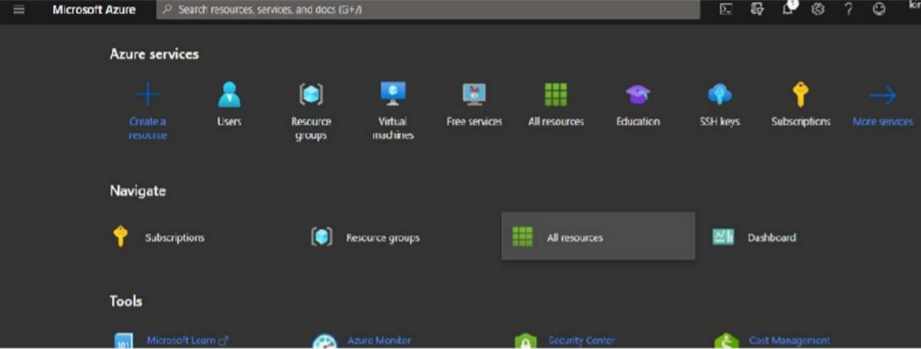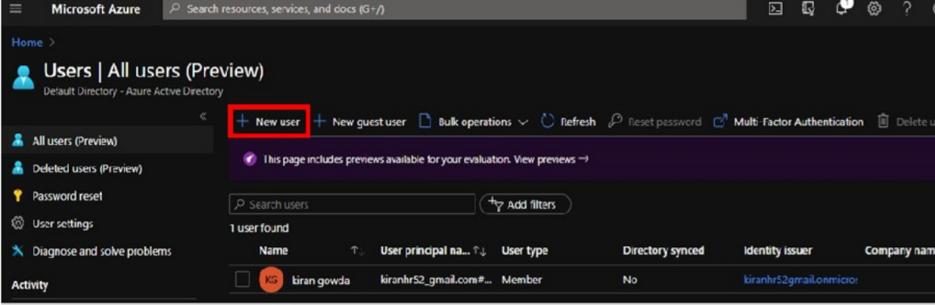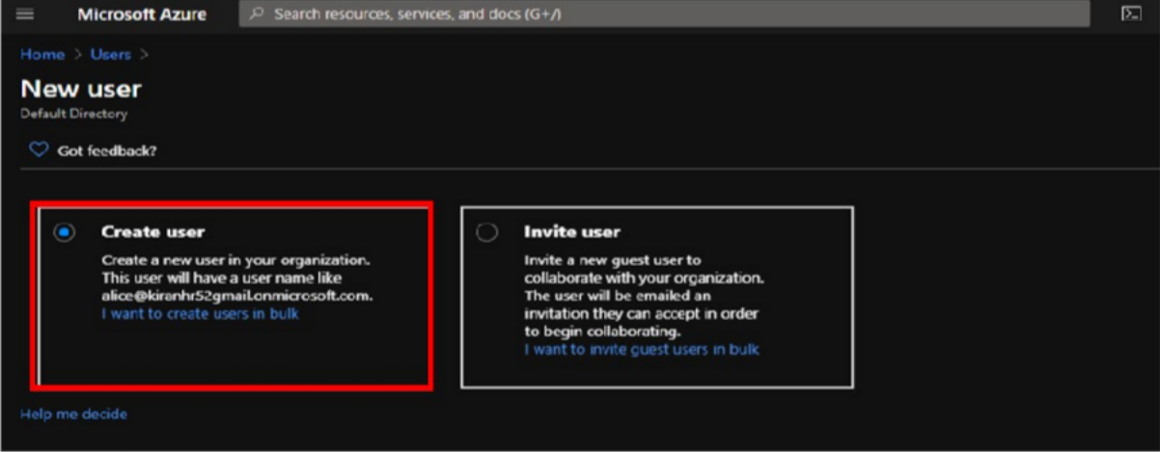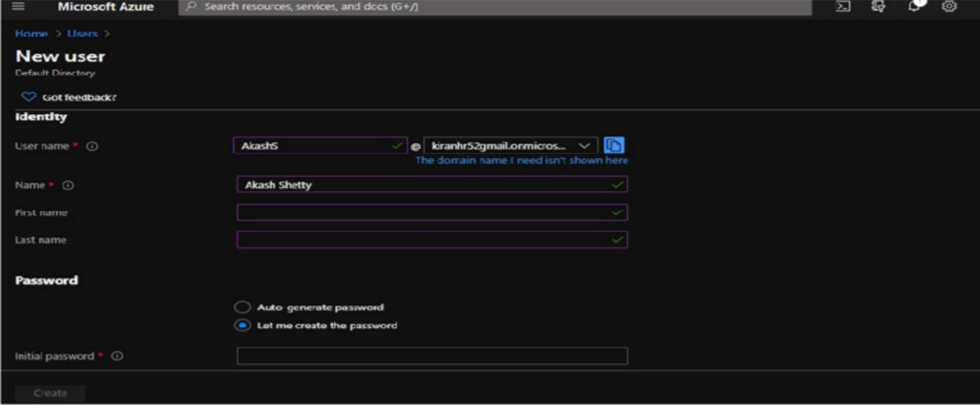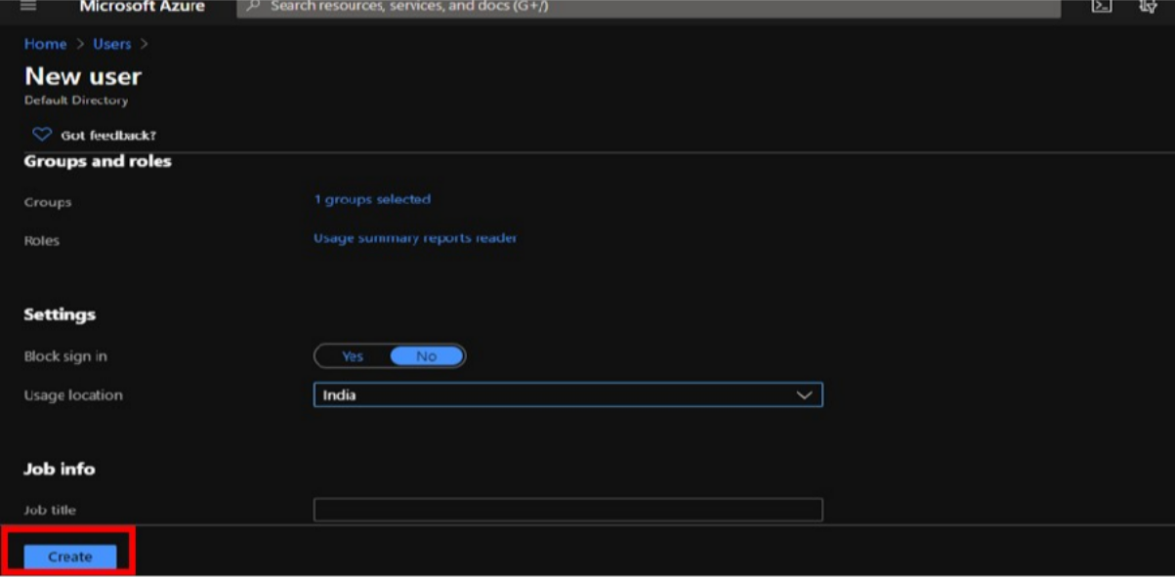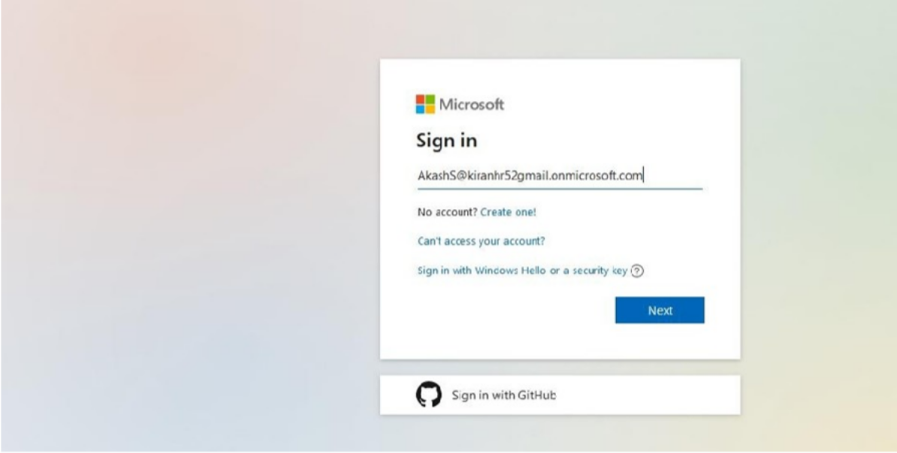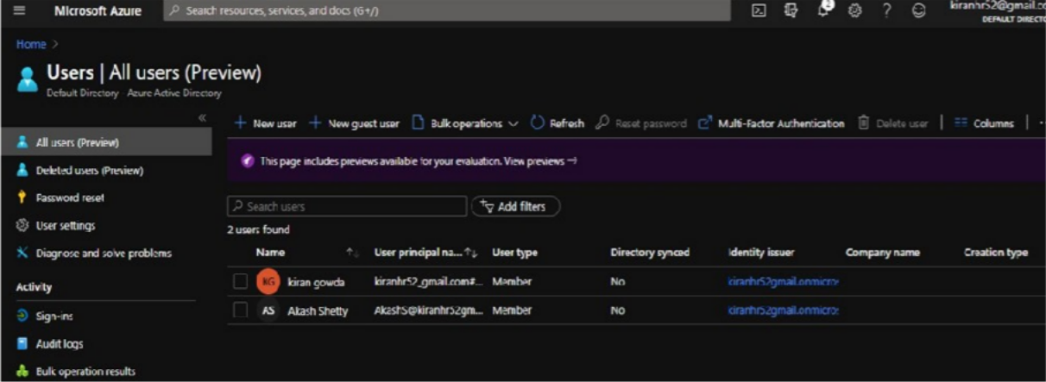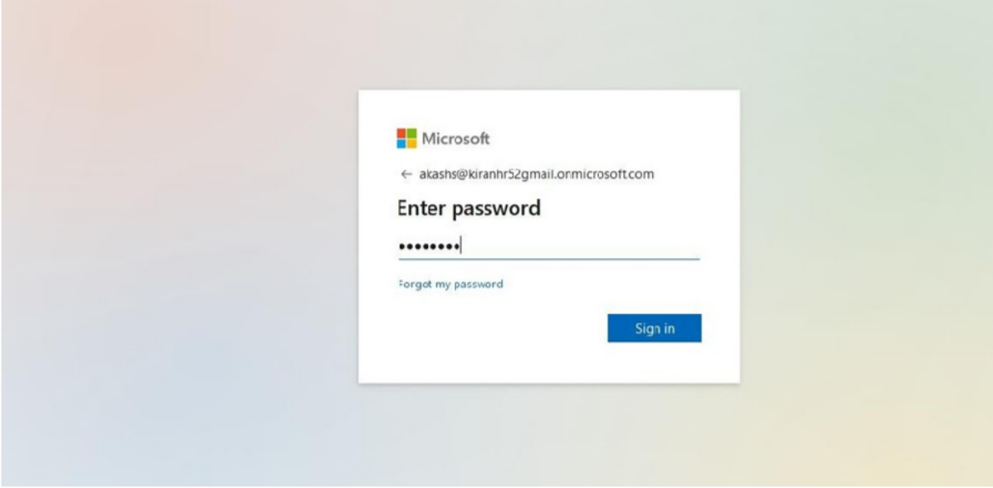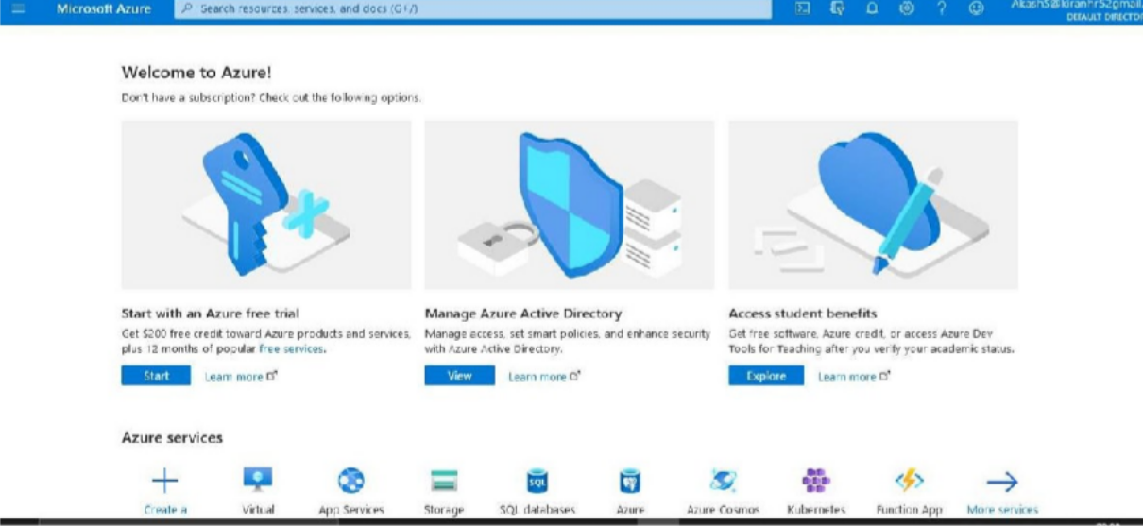

Conclusion : Successfully Performed User management in Azure